**NAME : SREE SANTHIKRISHNA S**

**REG NO : 727721EUCS149**

**CA – 1**

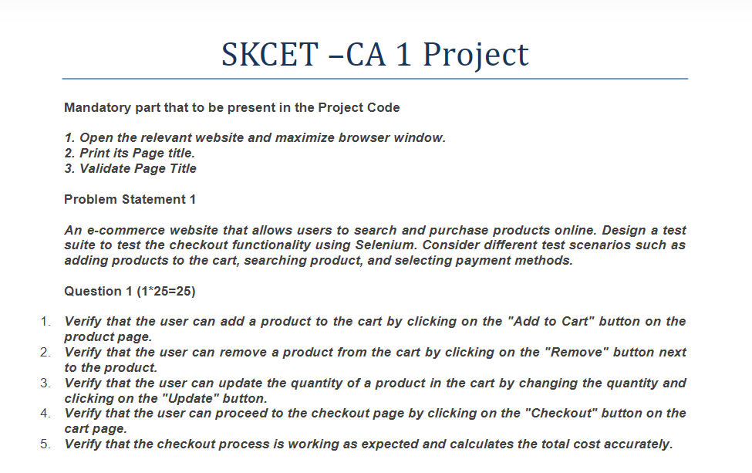

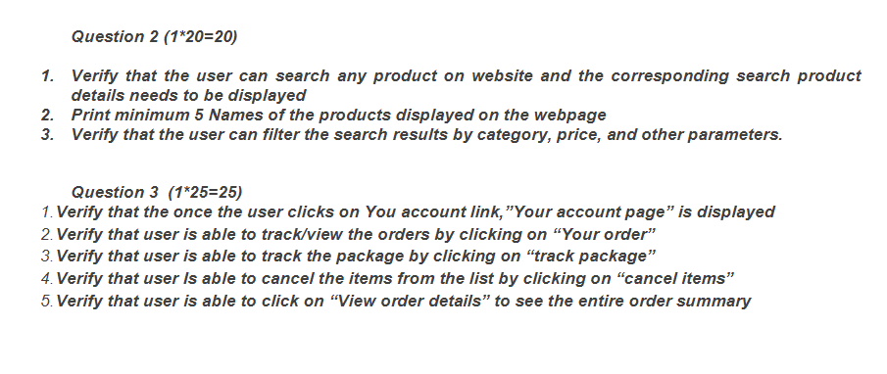

**CODE :**

**QUESTION 1 :**

package ca1;

import org.openqa.selenium.By;

import org.openqa.selenium.JavascriptExecutor;

import org.openqa.selenium.WebDriver;

import org.openqa.selenium.chrome.ChromeDriver;

import org.openqa.selenium.chrome.ChromeOptions;

import io.github.bonigarcia.wdm.WebDriverManager;

public class Question_1 {

public static void main(String[] args) throws InterruptedException {

// TODO Auto-generated method stub

ChromeOptions co = new ChromeOptions();

co.addArguments("--remote-allow-orginis=*");

WebDriverManager.chromedriver().setup();

WebDriver driver = new ChromeDriver();

driver.get("https://www.amazon.in/");

driver.manage().window().maximize();

String actualTitle=driver.getTitle();

String expectedTitle="Online Shopping site in India: Shop Online for Mobiles, Books, Watches, Shoes and More - Amazon.in";

if(expectedTitle.equals(actualTitle)) {

System.out.println("Title MATCHED");

}

else {

System.out.println("Title DID NOT MATCH");

}

driver.findElement(By.xpath("/html/body/div[1]/header/div/div[1]/div[2]/div/form/div[2]/div[1]/input")).sendKeys("macbook");

driver.findElement(By.xpath("/html/body/div[1]/header/div/div[1]/div[2]/div/form/div[3]/div/span/input")).click();

driver.findElement(By.xpath("/html/body/div[1]/div[2]/div[1]/div[1]/div/span[1]/div[1]/div[1]/div/div/div[1]/div[2]/div[1]/div/div[1]/a/div/img")).click();

JavascriptExecutor js = (JavascriptExecutor) driver;

js.executeScript("window.scrollBy(0,700)", "");

driver.findElement(By.xpath("/html/body/div[4]/div[2]/div[3]/div[8]/div[7]/div/div[1]/div/div[1]/div/div/div[2]/div/div[2]/div/form/div/div/div[32]/div[1]/span/span/span/input")).click();

Thread.sleep(3000);

String str1=driver.findElement(By.xpath("/html/body/div[8]/div[3]/div[3]/div/div[1]/div[3]/div[1]/div[1]/div/div[1]/span")).getText();

if(str1.equals("Added to Cart")) {

System.out.println("Item added to cart");

}

else {

System.out.println("Item not added");

}

Thread.sleep(3000);

driver.findElement(By.xpath("/html/body/div[8]/div[3]/div[3]/div/div[1]/div[3]/div[1]/div[2]/div[3]/form/span/span/input")).click();

driver.findElement(By.xpath("/html/body/div[1]/div[2]/div[3]/div[5]/div/div[2]/div[1]/div/form/div[2]/div[3]/div[4]/div/div[2]/div[1]/span[1]/span/span[1]/span/span/span/span")).click();

driver.findElement(By.xpath("/html/body/div/div/div/div[1]/div[1]/div[3]/a")).click();

String str2=driver.findElement(By.xpath("/html/body/div[1]/div[2]/div[3]/div[5]/div/div[2]/div[1]/div/form/div[2]/div[3]/div[4]/div/div[3]/div[1]/span[1]/span/span[1]/span/span/span/span")).getText();

if(str2.equals("Update")) {

System.out.println("Quantity of product is changed");

}

else {

System.out.println("Quantity of product is not changed");

}

driver.findElement(By.xpath("/html/body/div[3]/div/div/ul/li[5]/a")).click();

String str3=driver.findElement(By.xpath("/html/body/div/div/div/div[1]/div[2]/span")).getText();

if(str3.equals("Item removed")) {

System.out.println("Item has been removed");

}

else {

System.out.println("Item has not been removed");

}

driver.findElement(By.xpath("/html/body/div[1]/div[2]/div[3]/div[5]/div/div[2]/div[1]/div/form/div[2]/div[3]/div[4]/div/div[2]/div[1]/span[2]/span/input")).click();

String str4=driver.findElement(By.xpath("/html/body/div[1]/div[2]/div[3]/div[5]/div/div[2]/div[1]/div/form/div[2]/div[3]/div[4]/div/div[2]/div[1]/span[2]/span/input")).getText();

if(str4.equals("Checkout")) {

System.out.println("Checkout page is displayed");

}

else {

System.out.println("Checkout page is not displayed");

}

driver.findElement(By.xpath("/html/body/div/div/div[2]/div[1]/div/div/form/div[1]/input")).sendKeys("8870253109");

driver.findElement(By.xpath("/html/body/div/div/div[2]/div[1]/div/div/form/div[2]/input")).sendKeys("Rajianu123");

driver.findElement(By.xpath("/html/body/div/div/div[2]/div[1]/div/div/form/input")).click();

Thread.sleep(8000);

String str5=driver.findElement(By.xpath("/html/body/div[1]/div[2]/div[3]/div[5]/div/div[2]/div[1]/div/form/div[2]/div[3]/div[4]/div/div[2]/div[1]/span[2]/span/input")).getText();

if(str5.equals("Order Summary")) {

System.out.println("Checkout process is working");

}

else {

System.out.println("Checkout process is not working");

}

driver.close();

}

}

**OUTPUT :**

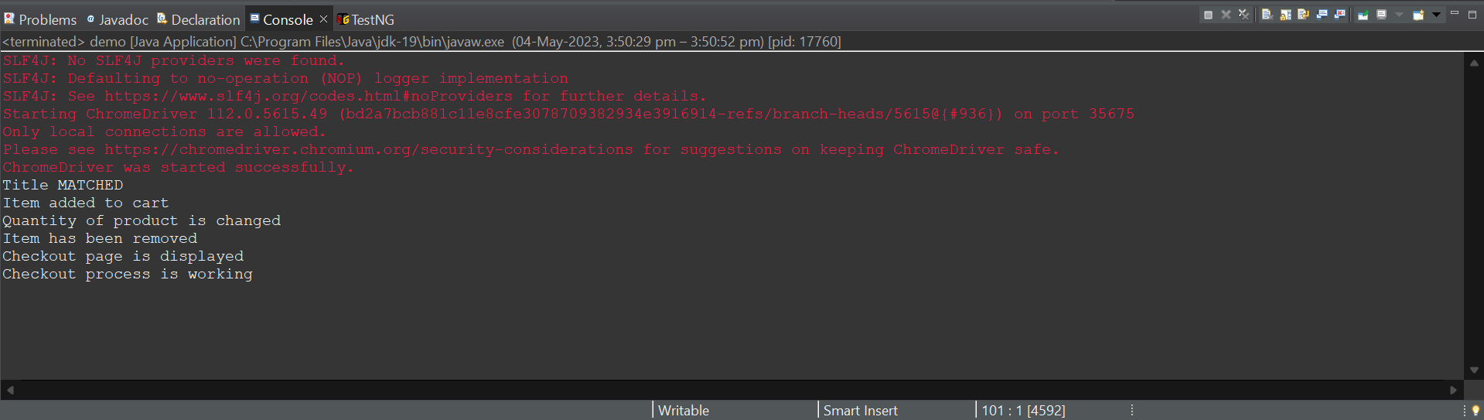

**QUESTION 2 :**

package ca1;

import org.openqa.selenium.WebElement;

import org.openqa.selenium.chrome.ChromeDriver;

import org.openqa.selenium.chrome.ChromeOptions;

import io.github.bonigarcia.wdm.WebDriverManager;

import org.openqa.selenium.By;

import org.openqa.selenium.WebDriver;

public class Question_2 {

public static void main(String[] args) {

// TODO Auto-generated method stub

ChromeOptions co=new ChromeOptions();

co.addArguments ("--remote-allow-origins=*");

WebDriverManager.chromedriver().setup ();

WebDriver driver=new ChromeDriver(co);

driver.get ("https://www.amazon.in/");

driver.manage().window().maximize() ;

String currentTitle=driver.getTitle();

String expectedTitle="Online Shopping site in India: Shop Online for Mobiles, Books, Watches, Shoes and More - Amazon.in";

if(currentTitle.equals(expectedTitle)) {

System.out.println("Title Matched");

}

else {

System.out.println("Title not Matched");

}

WebElement txtBoxl=driver.findElement(By.xpath("//*[@id=\"twotabsearchtextbox\"]"));

txtBoxl.sendKeys("macbook");

driver.findElement(By.xpath("//*[@id=\"nav-search-submit-button\"]")).click();

String txt1=driver.findElement(By.xpath("//*[@id=\"search\"]/div[1]/div[1]/div/span[1]/div[1]/div[3]/div/div/div/div/div/div/div/div[2]/div/div/div[1]/h2/a/span")).getText();

System.out.println(txt1);

String txt2=driver.findElement(By.xpath("//*[@id=\"search\"]/div[1]/div[1]/div/span[1]/div[1]/div[4]/div/div/div/div/div/div/div/div[2]/div/div/div[1]/h2/a/span")).getText();

System.out.println(txt2);

String txt3=driver.findElement(By.xpath("//*[@id=\"search\"]/div[1]/div[1]/div/span[1]/div[1]/div[5]/div/div/div/div/div/div[2]/div/div/div[1]/h2/a/span")).getText();

System.out.println(txt3);

String txt4=driver.findElement(By.xpath("//*[@id=\"search\"]/div[1]/div[1]/div/span[1]/div[1]/div[6]/div/div/div/div/div/div[2]/div/div/div[1]/h2/a/span")).getText();

System.out.println(txt4);

String txt5=driver.findElement(By.xpath("//*[@id=\"search\"]/div[1]/div[1]/div/span[1]/div[1]/div[7]/div/div/div/div/div/div[2]/div/div/div[1]/h2/a/span")).getText();

System.out.println(txt5);

//filter

driver.findElement(By.xpath("//*[@id=\"p_36/7252032031\"]/span/a/span")).click();

driver.findElement(By.xpath("//*[@id=\"p_n_pattern_browse-bin/1464446031\"]/span/a/span")).click();

}

}

**OUTPUT :**

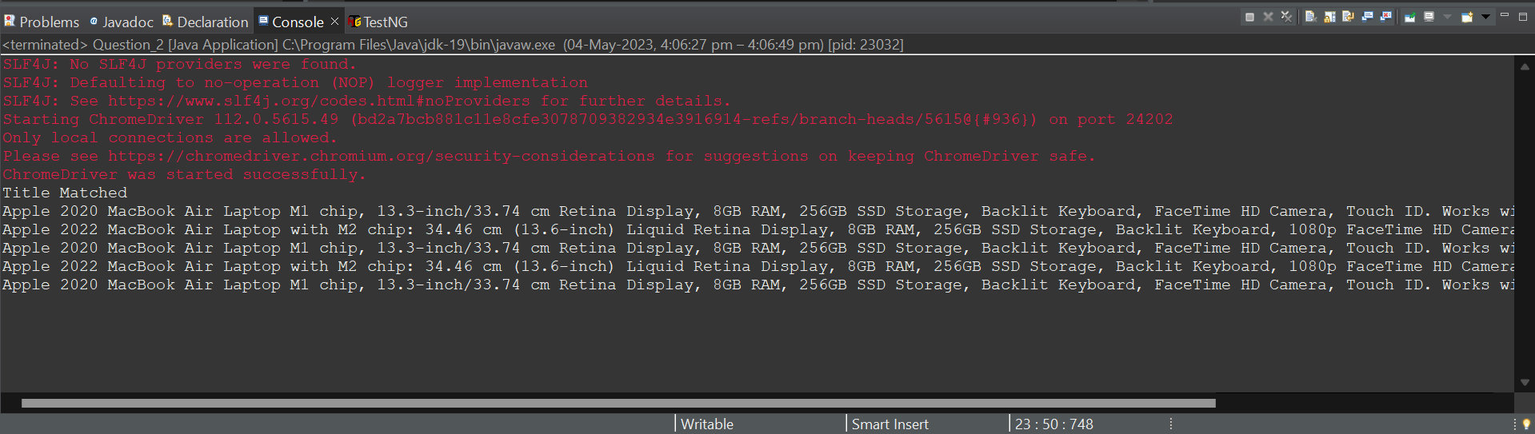

**QUESTION 3 :**

package ca1;

import org.openqa.selenium.By;

import org.openqa.selenium.WebDriver;

import org.openqa.selenium.chrome.ChromeDriver;

import org.openqa.selenium.chrome.ChromeOptions;

import io.github.bonigarcia.wdm.WebDriverManager;

public class Ouestion_3 {

public static void main(String[] args) throws InterruptedException {

// TODO Auto-generated method stub

ChromeOptions co = new ChromeOptions();

co.addArguments("--remote-allow-orginis=*");

WebDriverManager.chromedriver().setup();

WebDriver driver = new ChromeDriver();

driver.get("https://www.amazon.in/");

driver.manage().window().maximize();

String actualTitle=driver.getTitle();

String expectedTitle="Online Shopping site in India: Shop Online for Mobiles, Books, Watches, Shoes and More - Amazon.in";

if(expectedTitle.equals(actualTitle)) {

System.out.println("Title MATCHED");

}

else {

System.out.println("Title DID NOT MATCH");

}

driver.findElement(By.xpath("/html/body/div/div/div[2]/div[1]/div/div/form/div[1]/input")).sendKeys("8870253109");

driver.findElement(By.xpath("/html/body/div/div/div[2]/div[1]/div/div/form/div[2]/input")).sendKeys("Rajianu123");

driver.findElement(By.xpath("/html/body/div/div/div[2]/div[1]/div/div/form/input")).click();

Thread.sleep(8000);

driver.findElement(By.xpath("/html/body/div[1]/header/div/div[1]/div[3]/div/a[2]/span")).click();

driver.findElement(By.xpath("/html/body/div[1]/header/div/div[3]/div[2]/div[2]/div/div[2]/a[1]/span")).click();

Thread.sleep(3000);

String str1=driver.findElement(By.xpath("/html/body/div[8]/div[3]/div[3]/div/div[1]/div[3]/div[1]/div[1]/div/div[1]/span")).getText();

if(str1.equals("Your Account")) {

System.out.println("Your account page is displayed");

}

else {

System.out.println("Your account page is not displayed");

}

Thread.sleep(3000);

driver.findElement(By.xpath("/html/body/div[1]/div[2]/div/div[2]/div[1]/a/div/div/div/div[2]/div/span")).click();

String str2=driver.findElement(By.xpath("/html/body/div[1]/section/div[1]/div[2]/div[1]/h1")).getText();

if(str2.equals("Your Orders")) {

System.out.println("Your orders page is displayed");

}

else {

System.out.println("Your orders page is not displayed");

}

driver.close();

}

}

**OUTPUT :**

